# PROJECT REPORT TEMPLATE

PLUGGING INTO THE FUTURE:

AN EXPLORATION OF ELECTRICITY CONSUMPTION PATTERN

1.INTRODUCTION

* 1. OVERVIEW

### In Conventional Energy in North America, 2019

### Electricity consumption is an essential component of the modern life. It not only provides clean and safe light throughout the day, but also in many countries refreshes homes on hot summer days, and in others warms them in winter. In all countries, it allows the use of electrical and electronic equipment in which the use of electricity is essential to ensure their proper functioning. Although hundreds of millions of Americans and Canadians connect to the power grid every day, most of them do not think about how they get the electricity consumed, and how much it costs to produce it. Keeping the North America region energized is actually an amazing feat, a daily miracle.

Electricity Consumption

### Global electricity consumption has continued to go up rapidly at a rate faster than energy consumption. Between 1980 and 2013, the world’s annual electricity consumption rose from 7300 TWh to 22,100 TWh. Since the twenty first century, global electricity consumption has seen even faster growth, as evidenced by an average annual increase of 3.4%, 1.2 percentage points higher than average annual growth of energy consumption.

* 1. PURPOSE

### Annual electricity consumption per capita serves as **an important measure of a country's electric power development**. Generally speaking, electricity consumption grows faster when the industrialization process develops quickly and goes down rapidly when industrialization is completed or near completion.

### Starting from toasters to refrigerators, microwaves, washing machines, dishwashers, electrical chimneys, and many more appliances which are simple to use and made for the convenience of day-to-day activities use electricity to function.

2.PROBLEM DEFINITION AND DESIGING THINKING

2.1 EMPATHY MAP

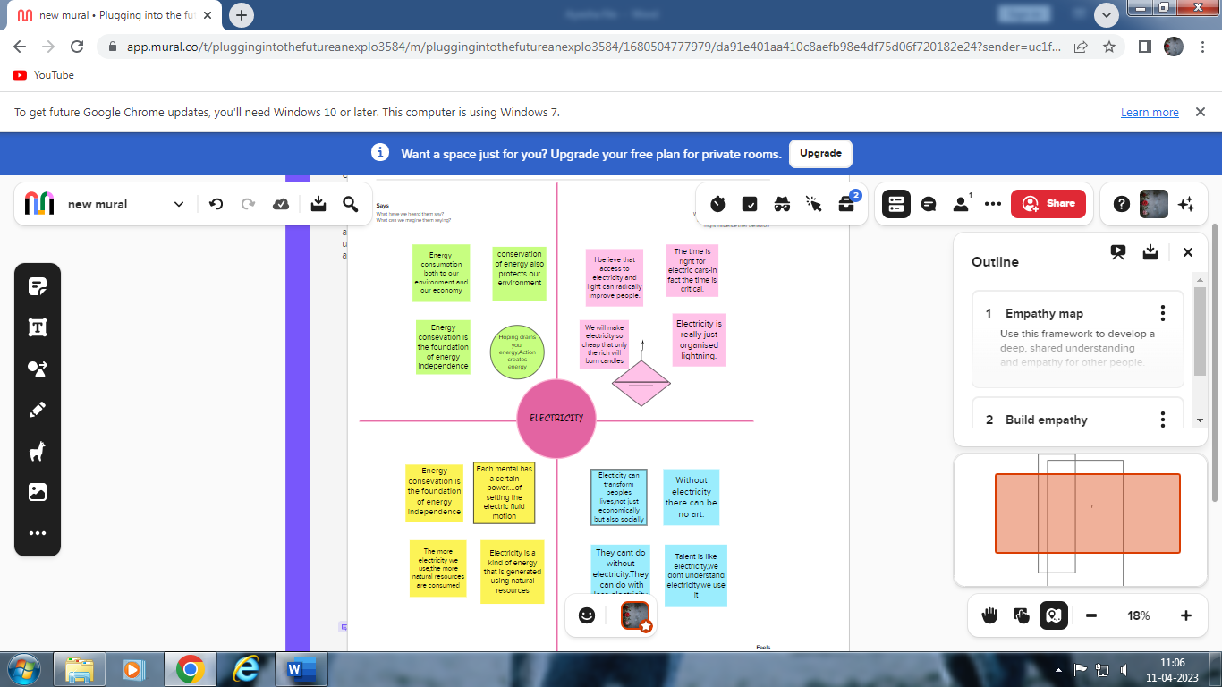

2.2 IDEATION AND BRAINSTROM

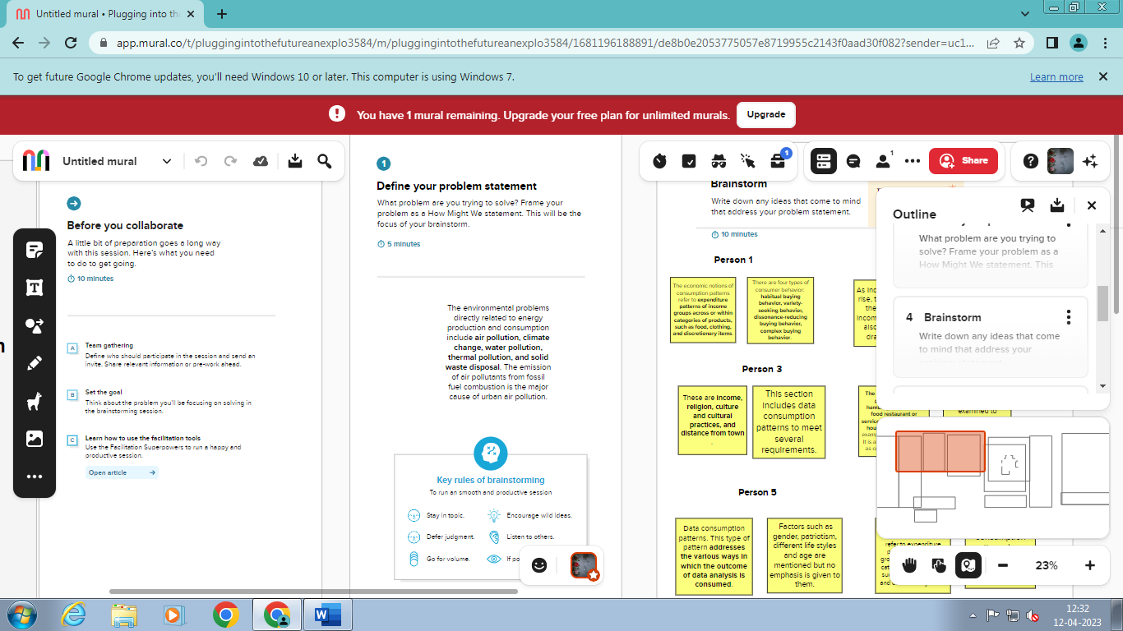 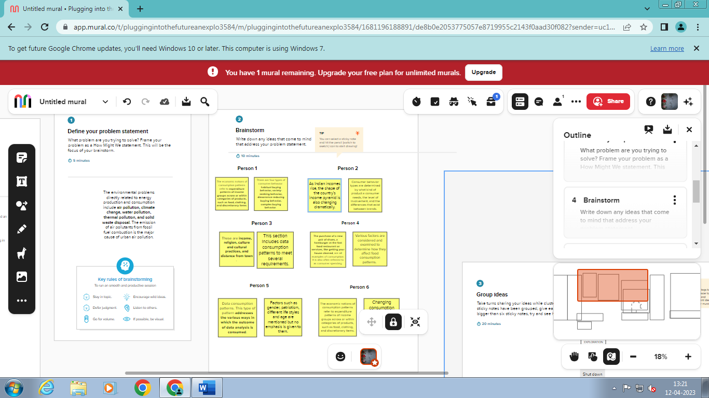

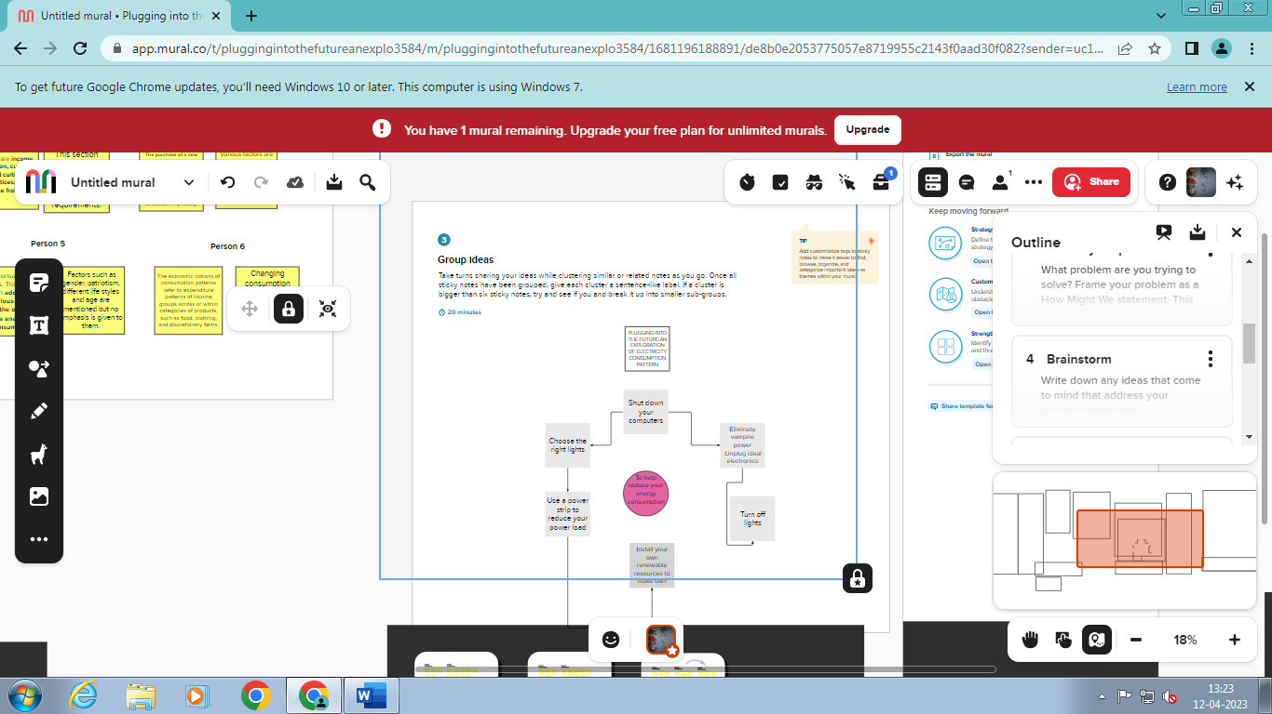

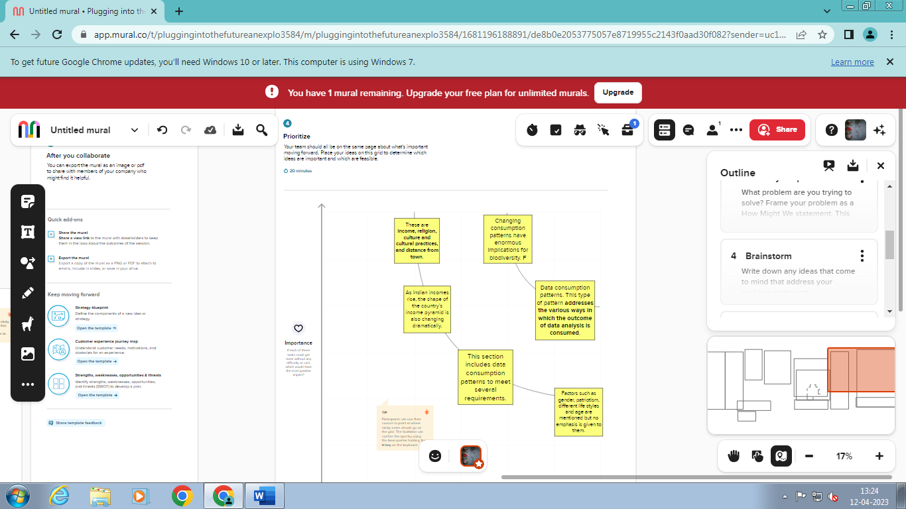

3.RESULT

### In Problem definition and design thinking we have created a empathy map with our topic related to - Plugging into future: An exploration of electricity consumption pattern.

### In that we have explained the process, control and uses of electricity consumption.

### In ideation and brainstorm mapping we have created 4 types of column based on several types of questions .We have answered and typed our thoughts and ideas in that map.

### *Define a problem ,brainstorm ,group ideas , prioratize are the types of columns we have filled.

### 12 types of ideas and information are given in the brainstorm by our team members.

### 6 types of ideas are given and make a graph in the prioratize.

4.ADVANTAGES AND DISADVANTAGES

ADVANTAGE :

Using less energy can reduce your business energy costs, but an effective energy efficiency strategy can also improve your brand's reputation, protect your business against volatile energy markets, improve employee productivity and help save the planet.

### Cost-effective energy efficiency improvements can have positive macroeconomic impacts, **boosting economic activity and often leading to increased employment**. Energy efficiency reduces the amount of energy needed to deliver services, such as mobility, lighting, heating and cooling.

### DISADVANTAGE:

### A natural consequence of overusing energy is increased costs for you. This can come in the form of fuel and energy bills; you will be paying more without an appreciable return on your investment. You may also risk lowering the expected lifespan of appliances and other electronics.

### Higher maintenance requirement.

5.APPLICATIONS

### The lights, lifts, AC, coffee machine, ID card reader, biometric scanners and everything else require electricity.

### Electric cells are used as a source of electricity in torches, wristwatches, alarm clocks, transistor, radios, TV remotes, cameras, mobile phone, toys and many other devices.

### *electricity—all types of energy end uses.

### *natural gas—space and water heating, clothes drying, cooking.

### *heating oil—space and water heating, clothes drying.

### *LPG/propane—space and water heating, clothes drying, cooking.

### *kerosene—space heat.

### 

6.CONCLUSION

### The discovery of electricity was a turning point of history because without it we wouldnt live in the world that we live in today which is filled with life changing technology but it all needs and uses electricity. Without  electricity you wouldnt be able to view this page or be on a computer at this very moment. Electricity is something that we all live by whether we notice it or not, some of us wouldnt be able to survive without it because it is a must needed source to our everyday lives. It is used to help save people, in education, hospitals, cities, etc., we live by this incredible creation that mother nature has given us and we have been able to control it with our very own hands throughout centuries. Especially in this crazy changing world where things are being invented and created everyday, it would not be possible without "Electricity".

### 

7.FUTURE SCOPE

### Electrical engineers can also apply for respective and relevant vacancies coming out of State-Electricity Boards, PWD department, Thermal Power Plants, Nuclear Power Stations, Hydro-electric Power Stations, Solar Power plants, Indian Army, Indian Airforce, Indian Navy, and Indian Railways.

### Electricity will largely replace petrol and diesel as a fuel for road vehicles. It will also replace the natural gas and oil we burn to heat our homes and run our industries. In short, electricity will grow in importance as a carbon-free energy carrier.